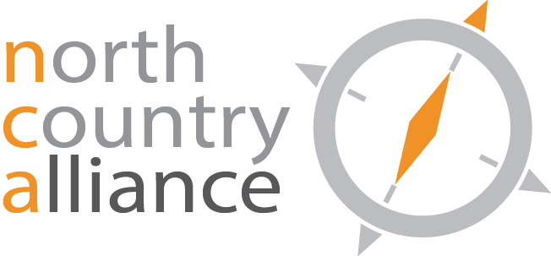

NCA Education and Outreach Committee
AGENDA
September 2, 2021
Zoom Meeting

- Review and Accept Updated Agenda

